Activity Well Prayed Iman!

Mosque
The sacred space for adherents of Islam is a mosque. Like churches and synagogues these are beautiful buildings. Some countries with a large Muslim population include – Afghanistan, Bangladesh, Chad and Cyprus.
Use Google image search to find a famous mosque from each country. Insert the image and label it below with the country and name of the mosque. Do they all have similar architectural features?
Image | Name of Mosque/Country

Iman
An Iman is the name given to the leader of an Islamic congregation. While there is not a standard dress code for Iman, they usually wear clothes that are appropriate to the country and climate. The clothes however must allow for easy bending movement during rituals. The clothing code does extend more strictly to Muslim women. Choose one picture, either the Iman or the woman and label at 2-3 parts of their outfit using this site to assist you: http://www.reflectionsofiman.com/
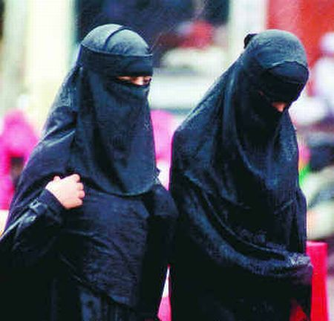
Salat
One of the Five Pillars of Islam is Salat (prayer). Muslims must pray 5 times each day. Use the internet and mark on the clocks (and label them) what ideal times prayer takes place.

Wudu
Just like Christians have the holy water to bless their mind, heart and body upon entering a church, the Islamic faith has a procedure called wudu that must be adhered to before entering a mosque. Check out the process here: http://www.wikihow.com/Perform-Wudu
Pause, Record, Share:
- What can you conclude about the significance of water for Islam?
- Why do you think so many steps are necessary?

Hajj
One of the Five Pillars of Islam is Hajj – the annual pilgrimage to Mecca. Check out the footage in the clip http://www.youtube.com/watch?v=0m03pCXxpKo (1 min 30 sec)

Ramadan
View clip at http://www.youtube.com/watch?v=ZSfIYIBsqLc and view pictures at http://www.theatlantic.com/infocus/2013/07/photos-of-ramadan-2013/100550/.
How would Australian teenagers keep busy if they had to fast from dawn to dusk? Design a simple game to play in small groups.

